" Cyclone Trends in Arabian Sea and Bay of Bengal"

## M.Sc. Agriculture Analytics

## Programming for Geodata Processing

## Name - Satyam Jotiram Kumbhar

## Student ID - TS90716

## Date of Submission - 18/01/2024

**Abstract**

This study focuses on the effects of rising sea surface temperatures in order to address the tendency of tropical cyclones in the North Indian Ocean becoming more frequent. In order to compare cyclonic activity in the Arabian Sea and Bay of Bengal, the study covers two separate time periods (1982-2000 and 2000-2023).

This study is driven by the pressing need to understand the dynamics of tropical cyclones as they intensify, especially in relation to the Arabian Sea. Densely inhabited coastal communities are at serious risk from the increasing frequency and intensity of cyclones in this region, which makes it imperative to fully comprehend the underlying mechanisms driving these changes.

The results indicate a significant rise of over 52% in cyclone activity over the Arabian Sea between the two periods. At the same time, the Arabian Sea's cyclonic intensity has demonstrated a notable rising tendency. By comparison, throughout the same period, there has been an 8% decline in the number of cyclones in the Bay of Bengal.

This study examines the increase in cyclone frequency and intensity in the Arabian Sea and attributes the trend to thermodynamic and geophysical causes, namely the effect of rising sea surface temperatures due to climate change. The study intends to clarify related dangers and improve our comprehension of the changing cyclonic landscape. The ultimate goal is to provide insights to support mitigation and preparedness plans for disasters in response to growing environmental concerns.

1. **Introduction**

* **Cyclone**

Cyclones are intense weather phenomena characterized by powerful swirling winds and storms. They form around low-pressure areas, where air rapidly circulates, creating turbulent weather conditions.

**Two types of cyclones:**

1. **Tropical Cyclones**

According to the World Meteorological Organisation (WMO, 1976), "Tropical Cyclone" refers to extreme weather systems with winds greater than "Gale Force," which is defined as at least 34 knots or 63 kph. These cyclones are created when the water and atmosphere work together and are heated by the sea. They are propelled by high planetary winds, temperate westerlies, easterly trade winds, and their own powerful energy.

1. **Extra Tropical Cyclones**

Extra Tropical Cyclones are seen in temperate zones and high latitude regions. They are known to originate in the Polar Regions.

* **Indian Meteorological Department**

The Indian Meteorological Department (IMD) developed the following classification system for low pressure systems in the Arabian Sea and Bay of Bengal based on their ability to cause damage.

1. Low Pressure = <17 Knots
2. Depression = 17-27 knots
3. Deep Depression = 27-33 knots
4. Cyclonic Storm = 33-47 knots
5. Severe Cyclonic Storm = 47-63 knots
6. Super Cyclone = >120 knots

**(1 knot - 1.85 km/hr)**

**Overview of Tropical Cyclones in North Indian Ocean:**

In the North Indian Ocean, thickly inhabited areas suffer severe damage from tropical storms. These cyclones are categorised by the IMD according to their highest wind speed for three minutes. Every year, four to five systems, on average, make it to the Cyclonic Storm (CS) stage. The Arabian Sea (AS) and the Bay of Bengal (BOB) are the two basins that make up the North Indian Ocean.AS compared to AS, BOB has more favourable ocean-atmospheric conditions for the genesis of tropical cyclones. BOB has three to four cyclones on average per year, which is four times more cyclone activity than AS.(references: Alam et al., 2003; Dube et al., 1997; Singh et al., 2001)

**1.1 Datasets**

**Sea Surface Temperature Dataset -**

Sea surface temperature (SST) data sets are an essential resource for monitoring and understanding climate variability and climate change. The Copernicus Marine Services which gives monthly sea surface temperature data from year 1993 to 2021.(https://marine.copernicus.eu/ocean-climate-portal/sea-surface-temperature)

**Frequency Of Cyclonic Systems In Indian Ocean Region Dataset-**

The Climate Data Service Portal (CDSP) of Indian Metrological Department Pune gives data about frequency of cyclones (https://cdsp.imdpune.gov.in/home_lab_1.php#allindiaRF). This dataset gives information about Cyclonic Disturbances, Cyclones, Sever Cyclonic Storms at Bay of Bengal, Arabian Sea, land and total each.

**Cyclone track dataset -**

The Tropical Cyclones division of the India Meteorological Department (IMD) in New Delhi, through the Regional Specialised Meteorological Centre (RSMC) - Tropical Cyclones, provides information on tropical storms, including the date of the cyclone, time (UTC), latitude and logitude of the location, central pressure (hPa), maximum sustained surface speed (kt), pressure drop at the centre, and grade from 1982 to 2023.(https://report.php?internal_menu=MzM=rsmcnewdelhi.imd.gov.in)

# **2.Research Question and Analysis**

1. **How has the rise in sea surface temperatures impacted cyclone patterns in the Arabian Sea over recent decades?**

Understanding unusual climate patterns globally involves examining changes in Sea Surface Temperature (SST) over the equatorial Pacific, particularly in the context of El-Nino-Southern Oscillation (ENSO). While the middle Indian Ocean experiences warmer ocean temperatures and unique convection patterns, it's not as pronounced as the Pacific Ocean. Researchers have extensively studied the transmission of year-to-year anomalies from the Indian monsoon region, focusing on the annual cycle and variability in SST over the tropical Indian and Pacific Oceans.

In recent decades, the Arabian Sea has experienced a significant warming, with sea surface temperatures rising by 1.2°C to 1.4°C compared to four decades ago. This warming trend raises concerns regarding its potential impact on the formation and intensity of cyclones.

The given graph shows time series graph of average change in sea surface temperature from year 1993 to 2021.

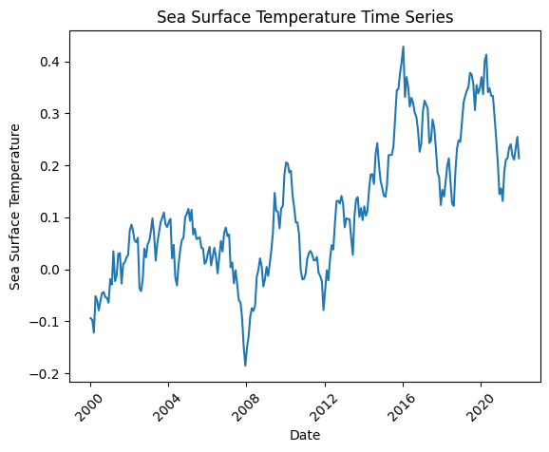

**Fig 1 - Change in Sea Surface Temperature from 1993-2021**

1. **What is the significance of the observed changes in frequency and intensity of cyclonic storms in the Arabian Sea and Bay of Bengal?**

From the dataset taken form The Climate Data Service Portal (CDSP) of Indian Metrological Department Pune. It gives information about cyclones and severe cyclones in both AS and BOB from year 1982 to 2023.

From Fig - 2 we get to know the number of cyclones are get increased in recent years. And as compared to cyclones and severe cyclones in Bay of Bengal (BOB), the number of cyclones and severe cyclones in Arabian Sea (AS) get increased from year 2001.

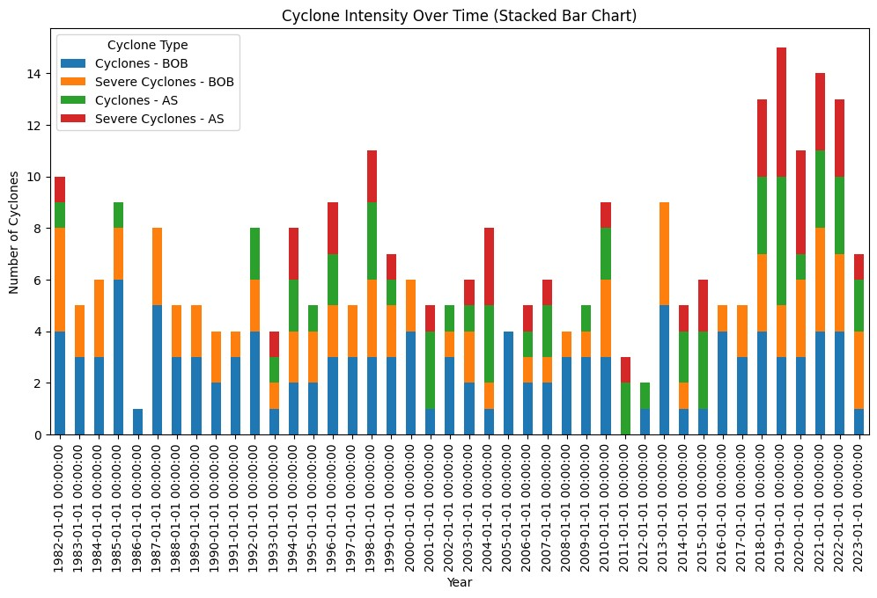**Fig 2 - Cyclone frequency over time**

As Fig 3 shows notable increase in cyclonic storm (CS) and very severe CS (VSCS) strength, frequency, and duration across the Arabian Sea. In Arabian Sea the cyclone intensity, duration of cyclone and frequency of cyclone get increased in last 10 years. The frequency of CS has increased by 52% in the last years (2001–2023).

There is an increase in cyclonic activity in the Arabian Sea, while the Bay of Bengal has a different trend. The same study reports that during the current years (2001–2023), the frequency of cyclonic storms in the Bay of Bengal has decreased by 8% (Fig - 4). For a thorough evaluation of cyclone danger, it is imperative to comprehend these divergent patterns.

**Fig 3- Cyclones and severe cyclones in Arebian Sea**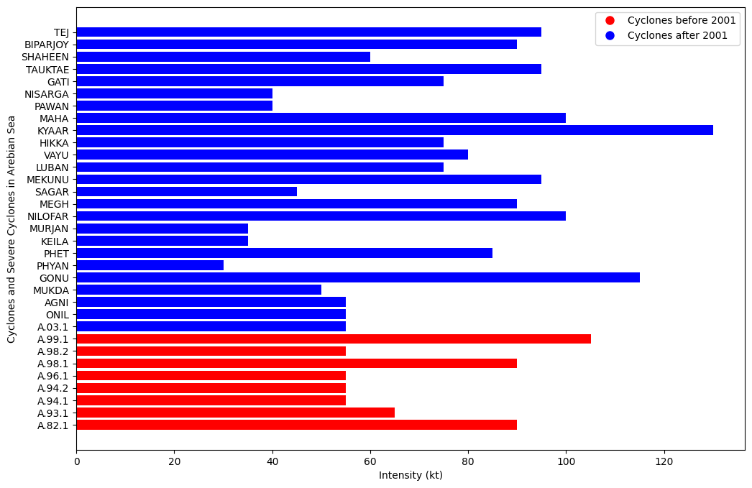

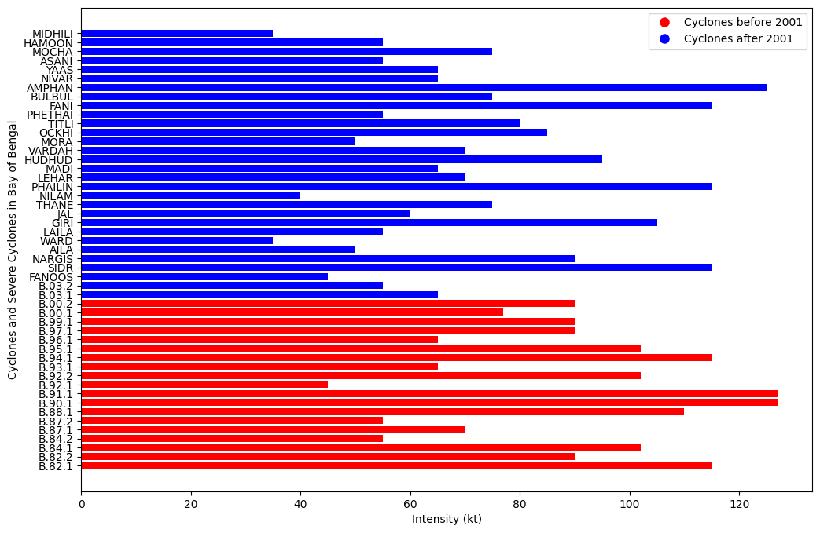

**Fig 4- Cyclones and severe cyclones in Bay of Bengal**

**Conclusion:**

In recent decades, the Arabian Sea's rising sea surface temperatures (SST) have become increasingly important in determining cyclone patterns. The trend of warming, which has increased by 1.2°C to 1.4°C in the last 40 years, raises questions about how it will affect the strength and development of cyclones. This warming trend is graphically depicted in the time series graph from 1993 to 2021, which offers important new information on how the Arabian Sea is evolving.

The observed changes in the frequency and intensity of cyclonic storms in the Arabian Sea and Bay of Bengal (BOB) carry substantial significance. Data obtained from The Climate Data Service Portal (CDSP) of the Indian Meteorological Department for the years 1982 to 2023 reveals a notable increase in the number of cyclones in recent years. Specifically, from 2001 onwards, the Arabian Sea has experienced a surge in both cyclones and severe cyclones. In contrast, the Bay of Bengal exhibits a different trend, with a decrease in the frequency of cyclonic storms.

The results highlight how critical it is to comprehend these varied patterns in order to assess cyclone hazard in its entirety. The increased cyclonic activity in the Arabian Sea presents difficulties for plans for catastrophe preparedness and mitigation. However, the declining trend of the Bay of Bengal calls for a more sophisticated strategy for managing cyclones in various areas. In light of changing climatic dynamics, it is essential to conduct ongoing study, monitor the situation, and develop adaption measures in order to effectively manage these obstacles.

Links to different journals/Articles referred -

1. News Articles-
2. <https://www.hindustantimes.com/india-news/arabian-sea-s-changing-character-increase-in-cyclones-and-sea-surface-temperatures-pose-threat-to-india-s-west-coast-101686559730299.html>
3. <https://www.newslaundry.com/2023/01/18/why-tropical-cyclones-are-rising-over-arabian-sea-shrinking-marginally-in-bay-of-bengal>
4. Journals - <https://www.researchgate.net/publication/353316671_Changing_status_of_tropical_cyclones_over_the_north_Indian_Ocean>

**References**

Alam MM, Hossain MA, Shafee S (2003) Frequency of Bay of Bengal cyclonic storms and depressions crossing different coastal zones. Int J Climatol 23:1119–1125. https://doi.org/10.1002/joc.927

Dube SK, Rao AD, Sinha PC et al (1997) Storm surge forecasting in the Bay of Bengal and Arabian Sea. Mausam 48:283–304

Singh OP, Khan TMA, Rahman MS (2001) Has the frequency of intense tropical cyclones increased in the north Indian Ocean? Curr Sci 80:575–580